InterpretML (Azure)
https://interpret.ml/
https://github.com/interpretml/interpret
Open-source package that incorporates state-of-the-art machine learning interpretability techniques. With this package, you can train interpretable glassbox models and explain blackbox systems. InterpretML helps you understand your model's global behavior, or understand the reasons behind individual predictions.
- Glass-box models are interpretable due to their structure. Examples include: Explainable Boosting Machines (EBM), Linear models, and decision trees. Glass-box models produce lossless explanations and are editable by domain experts.
- Black-box models are challenging to understand, for example deep neural networks. Black-box explainers can analyze the relationship between input features and output predictions to interpret models. Examples include LIME and SHAP.
- Supports global as well as local explanations, and things like subset prediction explanations as well as feature impact analysis.
- Supported techniques:
Explainable Boosting | glassbox model
Decision Tree | glassbox model
Decision Rule List | glassbox model
Linear/Logistic Regression | glassbox model
SHAP Kernel Explainer | blackbox explainer
LIME | blackbox explainer
Morris Sensitivity Analysis | blackbox explainer
Partial Dependence | blackbox explainer

AI Explainability 360 (IBM)
https://aix360.mybluemix.net/
https://github.com/Trusted-AI/AIX360
Open-source library that supports interpretability and explainability of datasets and machine learning models. The AI Explainability 360 Python package includes a comprehensive set of algorithms that cover different dimensions of explanations along with proxy explainability metrics.
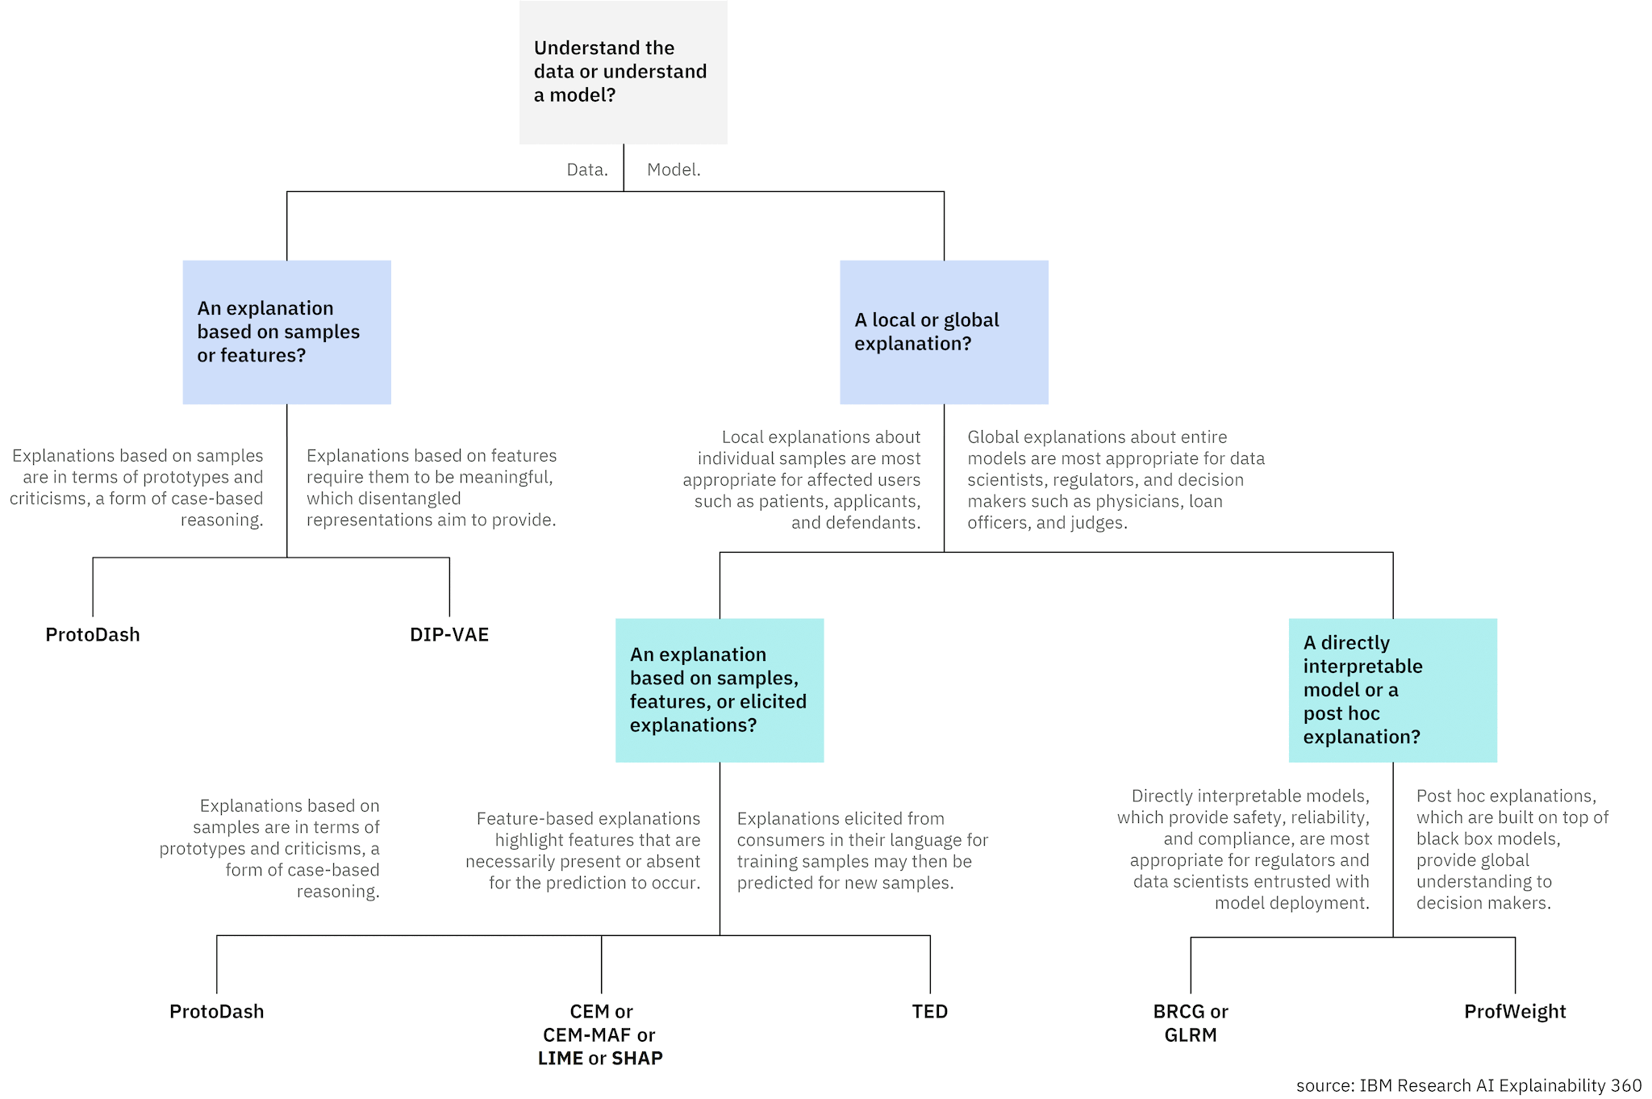
The algorithms in the toolkit are primarily intended for high-stakes applications of machine learning from data that support decision making with humans in the loop, either as the decision makers, the subjects of the decisions, or as regulators of the decision making processes. Other modes of AI such as knowledge graph induction or planning, and even other modes of machine learning such as reinforcement learning are not appropriate settings in which to use AIX360.
- Data explanation (ProtoDash (Gurumoorthy et al., 2019), Disentangled Inferred Prior VAE (Kumar et al., 2018))
- Local post-hoc explanation (ProtoDash (Gurumoorthy et al., 2019), Contrastive Explanations Method (Dhurandhar et al., 2018), Contrastive Explanations Method with Monotonic Attribute Functions (Luss et al., 2019), LIME (Ribeiro et al. 2016, Github), SHAP (Lundberg, et al. 2017, Github))
- Local direct explanation (Teaching AI to Explain its Decisions (Hind et al., 2019))
- Global direct explanation (Boolean Decision Rules via Column Generation (Light Edition) (Dash et al., 2018), Generalized Linear Rule Models (Wei et al., 2019))
- Global post-hoc explanation (ProfWeight (Dhurandhar et al., 2018)
- Supported explainability metrics (Faithfulness (Alvarez-Melis and Jaakkola, 2018), Monotonicity (Luss et al., 2019))
What if tool (Google People and AI Research)
https://pair-code.github.io/what-if-tool/
https://github.com/pair-code/what-if-tool
Visually probe the behavior of trained machine learning models, with minimal coding.
A key challenge in developing and deploying responsible Machine Learning (ML) systems is understanding their performance across a wide range of inputs.
Using WIT, you can test performance in hypothetical situations, analyze the importance of different data features, and visualize model behavior across multiple models and subsets of input data, and for different ML fairness metrics.
The What-If Tool can work with any python-accessible model in Notebook environments, and will work with most models hosted by TF-serving in Tensorboard.
The What-If Tool supports:
- binary classification*
- multi-class classification
- regression tasks
* Fairness optimization strategies are available only with binary classification models due to the nature of the strategies themselves.
In the What-If Tool, Counterfactuals are datapoints that are most similar to a selected datapoint, but are classified differently by a model.
For binary classification models, counterfactuals are the most similar datapoint to a selected datapoint that is predicted in the opposite class or label by a model.
For regression models, counterfactuals are calculated when the difference in prediction score between the selected datapoint and a candidate counterfactual is equal or greater to the “counterfactual threshold”. The counterfactual threshold default is set to the standard deviation of the prediction values and can be adjusted by the user.
For multi-class models, the counterfactual is the most similar datapoint to a selected datapoint, but is classified as any class other than the selected datapoint’s class.
Tensorwatch
https://github.com/microsoft/tensorwatch
TensorWatch is a debugging and visualization tool designed for data science, deep learning and reinforcement learning from Microsoft Research. It works in Jupyter Notebook to show real-time visualizations of your machine learning training and perform several other key analysis tasks for your models and data.
TensorWatch is designed to be flexible and extensible so you can also build your own custom visualizations, UIs, and dashboards. Besides traditional "what-you-see-is-what-you-log" approach, it also has a unique capability to execute arbitrary queries against your live ML training process, return a stream as a result of the query and view this stream using your choice of a visualizer (we call this Lazy Logging Mode).
When you write to a TensorWatch stream, the values get serialized and sent to a TCP/IP socket as well as the file you specified. From Jupyter Notebook, we load the previously logged values from the file and then listen to that TCP/IP socket for any future values. The visualizer listens to the stream and renders the values as they arrive.
Ok, so that's a very simplified description. The TensorWatch architecture is actually much more powerful. Almost everything in TensorWatch is a stream. Files, sockets, consoles and even visualizers are streams themselves. A cool thing about TensorWatch streams is that they can listen to any other streams. This allows TensorWatch to create a data flow graph. This means that a visualizer can listen to many streams simultaneously, each of which could be a file, a socket or some other stream. You can recursively extend this to build arbitrary data flow graphs. TensorWatch decouples streams from how they get stored and how they get visualized.
Rulex
https://www.rulex.ai/rulex-explainable-ai-xai/
Explainable AI produces transparent, easily understandable models. Using a series of if-then statements, Rulex automatically produces self-explanatory logic for all decisions. Rulex rulesets make it possible to explain a decision directly to the customer or provide customer service agents with the ability to look up the reason for a decision.
Why eXplainable AI is more transparent than black box?
The problem with conventional AI is very simple: it’s unexplainable. Conventional AI relies on machine learning algorithms such as neural networks and others that have one key feature in common: they produce “black box” predictive models, meaning they’re mathematical functions that cannot be understood by people, even mathematicians.
Rulex’s core machine learning algorithm, the Logic Learning Machine (LLM), works in an entirely different way from conventional AI. Rather than producing a math function, it produces conditional logic rules that predict the best decision choice, in plain language that is immediately clear to process professionals. Rulex rules make every prediction fully self-explanatory.
And unlike decision trees and other algorithms that produce rules, Rulex rules are stateless and overlapping, meaning one rule can cover many cases, and many rules can cover a single case. This allows for fewer, simpler rules and provides broader coverage at the same time.
Rulex calculates the coverage and accuracy of each rule, making it easy to select the most effective decision rules. Also, proven heuristic human rules can be added to the predictive model, allowing a seamless blend of human and artificial intelligence. Human rules are also rated for coverage and accuracy, allowing Rulex to easily evaluate the quality of the decision rules in use and reduce false positives.

MindsDB
https://mindsdb.com/
https://github.com/mindsdb/mindsdb
MindsDB's is an Explainable AutoML framework for developers. MindsDB is an automated machine learning platform that allows anyone to gain powerful insights from their data. With MindsDB, users can get fast, accurate, and interpretable answers to any of their data questions within minutes. A predictive layer for existing databases that enables rapid prototyping & deployment of ML Models from your database. Significantly reducing the time and cost of machine learning workflows.

Intuitive confidence measure
TO DO

Contrastive explanations
https://pythonrepo.com/repo/MarcelRobeer-ContrastiveExplanation-python-deep-learning-model-explanation
Contrastive Explanation provides an explanation for why an instance had the current outcome (fact) rather than a targeted outcome of interest (foil). These counterfactual explanations limit the explanation to the features relevant in distinguishing fact from foil, thereby disregarding irrelevant features. The idea of contrastive explanations is captured in this Python package ContrastiveExplanation. Example facts and foils are:
Machine Learning (ML) type | Problem | Explainable AI (XAI) question | Fact | Foil
Classification | Determine type of animal | Why is this instance a cat rather than a dog? | Cat | Dog
Regression analysis | Predict students' grade | Why is the predicted grade for this student 6.5 rather than higher? | 6.5 | More than 6.5
Clustering | Find similar flowers | Why is this flower in cluster 1 rather than cluster 4? | Cluster 1 | Cluster 4

Explainerdashboard
https://medium.com/value-stream-design/making-ml-transparent-and-explainable-with-explainerdashboard-49953ae743dd
https://github.com/oegedijk/explainerdashboard
https://www.youtube.com/watch?v=1nMlfrDvwc8
This package makes it convenient to quickly deploy a dashboard web app that explains the workings of a (scikit-learn compatible) machine learning model. The dashboard provides interactive plots on model performance, feature importances, feature contributions to individual predictions, "what if" analysis, partial dependence plots, SHAP (interaction) values, visualisation of individual decision trees, etc.
You can also interactively explore components of the dashboard in a notebook/colab environment (or just launch a dashboard straight from there). Or design a dashboard with your own custom layout and explanations (thanks to the modular design of the library). And you can combine multiple dashboards into a single ExplainerHub.
Dashboards can be exported to static html directly from a running dashboard, or programmatically as an artifact as part of an automated CI/CD deployment process.

